Project Design Phase-IITechnologyStack(Architecture&Stack)

|  |  |
| --- | --- |
| Date | 19October2023 |
| TeamID | ABDCDB652241D6FA0144AC94B95F5433 |
| ProjectName | Quantitative Analysis of Candidates In 2019 Lok Sabha |
| MaximumMarks | 4 Marks |

TechnicalArchitecture:

The Deliverable shall include the architectural diagram as below and the information asper the table1 & table 2

Reference: https://www.kaggle.com/datasets/prakrutchauhan/indian-candidates-for-general-election-2019

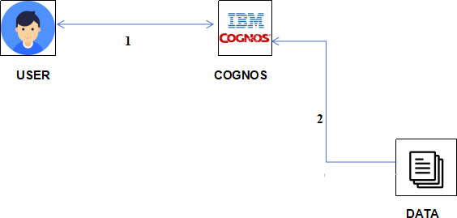

Guidelines:

1. Include allthe processes(As anapplicationlogic/TechnologyBlock)
2. Provideinfrastructuraldemarcation(Local/Cloud)
3. Indicateexternalinterfaces(thirdpartyAPI’setc.)
4. IndicateData Storagecomponents/ services
5. Indicateinterfacetomachinelearningmodels(ifapplicable)

Table-1:Components& Technologies:

|  |  |  |  |
| --- | --- | --- | --- |
| **S.No** | **Component** | **Description** | **Technology** |
| 1. | UserInterface | How user interacts with application e.g.WebUI,Mobile App,Chatbotetc. | HTML, CSS, JavaScript / Angular Js /ReactJsetc. |
| 2. | ApplicationLogic-1 | Logic fora processinthe application | Python |
| 3. | ApplicationLogic-2 | Logic fora processinthe application | IBMCognos Analytics |
| 4. | ApplicationLogic-3 | Logic fora processinthe application | IBMCognos Analytics |
| 5. | Database | DataType,Configurationsetc. | Excel |
| 6. | CloudDatabase | DatabaseServiceonCloud | IBMDB2, IBMCloudantetc. |
| 7. | FileStorage | Filestoragerequirements | IBM Block Storage or Other StorageService orLocal Filesystem |
| 8. | ExternalAPI-1 | PurposeofExternalAPI usedintheapplication | IBMWeatherAPI,etc. |
| 9. | ExternalAPI-2 | PurposeofExternalAPI usedintheapplication | AadharAPI,etc. |
| 10. | MachineLearningModel | PurposeofMachine Learning Model | ObjectRecognitionModel, etc. |
| 11. | Infrastructure(Server/Cloud) | Application Deployment on Local System / CloudLocalServerConfiguration:  CloudServerConfiguration: | Local,CloudFoundry,Kubernetes,etc. |

Table-2:ApplicationCharacteristics:

|  |  |  |  |
| --- | --- | --- | --- |
| **S.No** | **Characteristics** | **Description** | **Technology** |
| 1. | Open-SourceFrameworks | Listtheopen-sourceframeworksused | TechnologyofOpensourceframework |
| 2. | SecurityImplementations | List all the security / access controls implemented,useoffirewallsetc. | e.g. SHA-256, Encryptions, IAMControls,OWASP etc. |
| 3. | ScalableArchitecture | Justify the scalability of architecture (3 – tier,Micro-services) | Technology used |
| 4. | Availability | Justify the availability of application (e.g. use ofloadbalancers,distributed serversetc.) | Technology used |
| 5. | Performance | Design consideration for the performance of theapplication(number ofrequestspersec,useof  Cache,useofCDN’s)etc. | Technology used |

References:

https://www.kaggle.com/datasets/prakrutchauhan/indian-candidates-for-general-election-2019